

**BINUS UNIVERSITY**

**BINUS INTERNATIONAL**

**Assignment Cover Letter**

**(Individual Work****)**

|  |  |  |  |  |  |  |  |  |
| --- | --- | --- | --- | --- | --- | --- | --- | --- |
|  | | | | |  | |  | |
| **Student Information**: **Surname** | | | | | **Given Names**  **Dumac** | | **Student ID Number**  **2101699653** | |
| 1. | | **Revano Chen** |  | |
|  |  |
| **Course Code** | **: COMP6502** |  |  | | **Course Name** | | **: Introduction to Programming** | |
| **Class** | **: L1AC** |  |  | | **Name of Lecturer(s)** | | **:** 1. Ida Bagus Kerthyayana | |
|  |  |  |  | |  | | 2. Tri Asih Budiono | |
| **Major** | **: CS** |  |  | |  | |  | |
| **Title of Assignment**  (if any) | : Jet Mission (Video Game) | |  |  | |  | |  | |
| **Type of Assignment**    **Submission Pattern** | **: Final Project** |  |  | |  | |  | |
| **Due Date** | **: 7-11-2017** |  |  | | **Submission Date** | | **: 7-11-2017** | |

The assignment should meet the below requirements.

1. Assignment (hard copy) is required to be submitted on clean paper, and (soft copy) as per lecturer’s instructions.
2. Soft copy assignment also requires the signed (hardcopy) submission of this form, which automatically validates the softcopy submission.
3. The above information is complete and legible.
4. Compiled pages are firmly stapled.
5. Assignment has been copied (soft copy and hard copy) for each student ahead of the submission.

# Plagiarism/Cheating

BiNus International seriously regards all forms of plagiarism, cheating and collusion as academic offenses which may result in severe penalties, including loss/drop of marks, course/class discontinuity and other possible penalties executed by the university. Please refer to the related course syllabus for further information.

# Declaration of Originality

By signing this assignment, I understand, accept and consent to BiNus International terms and policy on plagiarism. Herewith I declare that the work contained in this assignment is my own work and has not been submitted for the use of assessment in another course or class, except where this has been notified and accepted in advance.

Signature of Student:

(Name of Student)

Dumac Revano Chen

“Jet Mission”

Student Name : Dumac Revano Chen

Student Id : 2101699653

1. **Introduction**

This game is created based on the simple aircraft shooting game. The objective of this game is to get a high score by shooting the meteor down and prevent getting struck by the meteor itself. The movement of the aircraft is based on the keyboard key pressed. This game run based on python 3 and Pygame, and the code used for this game is not copied from any other similar game that can be found on the online platform.

1. **Game’s files and code review**

**Classes.py**

This custom build module consists of a few classes which is used as the base of creating the objects in the game. These classes are built to be as flexible as possible so if any improvements are needed. Hence, redoing the whole code can be avoided. Here are the explanations for each class in this file:

Jet Class

This class is used as the base of the jet which players will control. This class affect the size, image, speed and the bullets that the jet will fire. The parameter screen in this class is used to decide on which surface the jet will be drawn. Besides this class also have four methods called as moveleft, moveup, moveright, movedown which control the movement of jet. Jet class also inherited the Sprite which is provided by the pygame library.

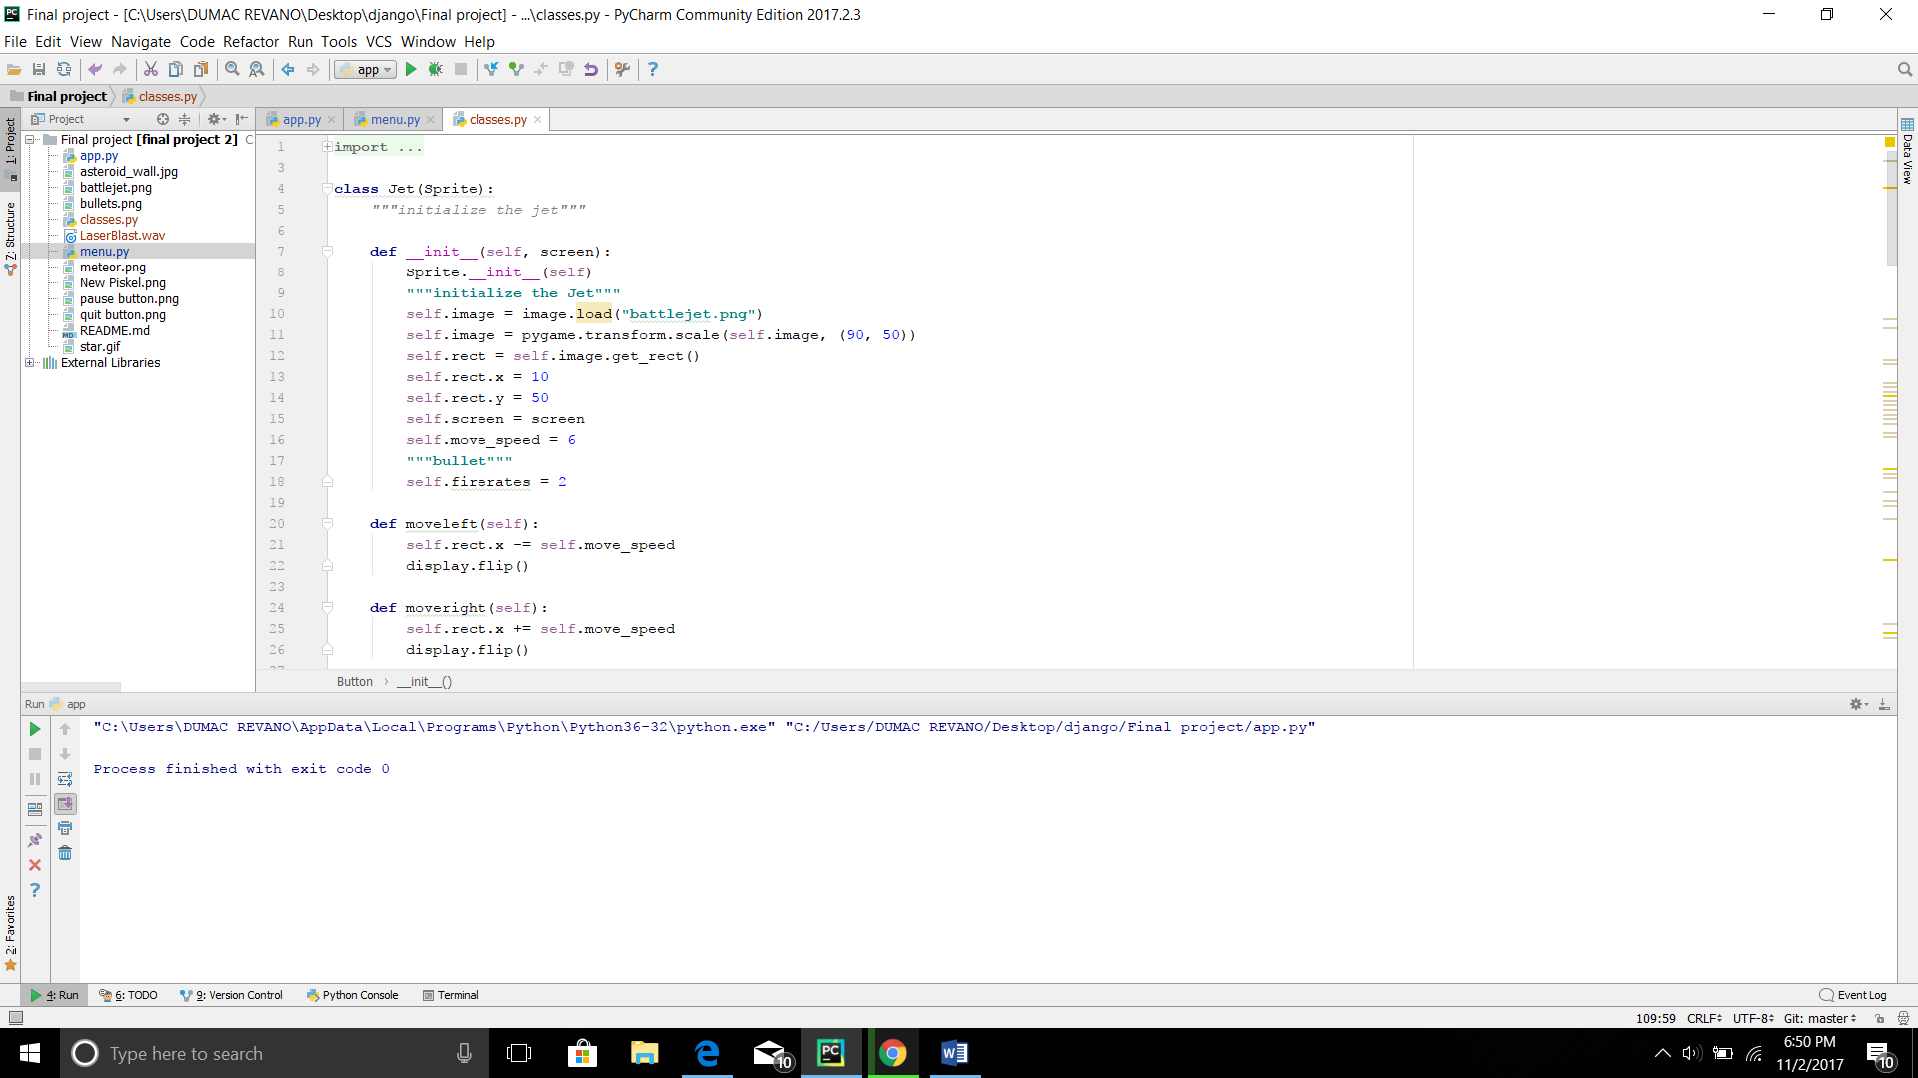

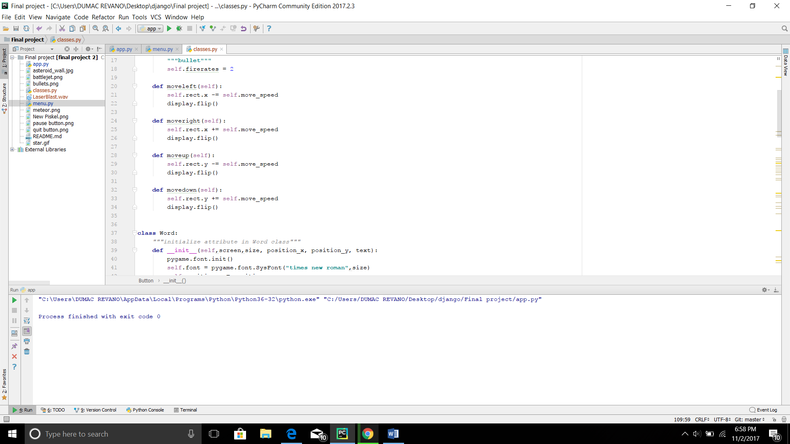

Example of calling the jet class and the inherited method :

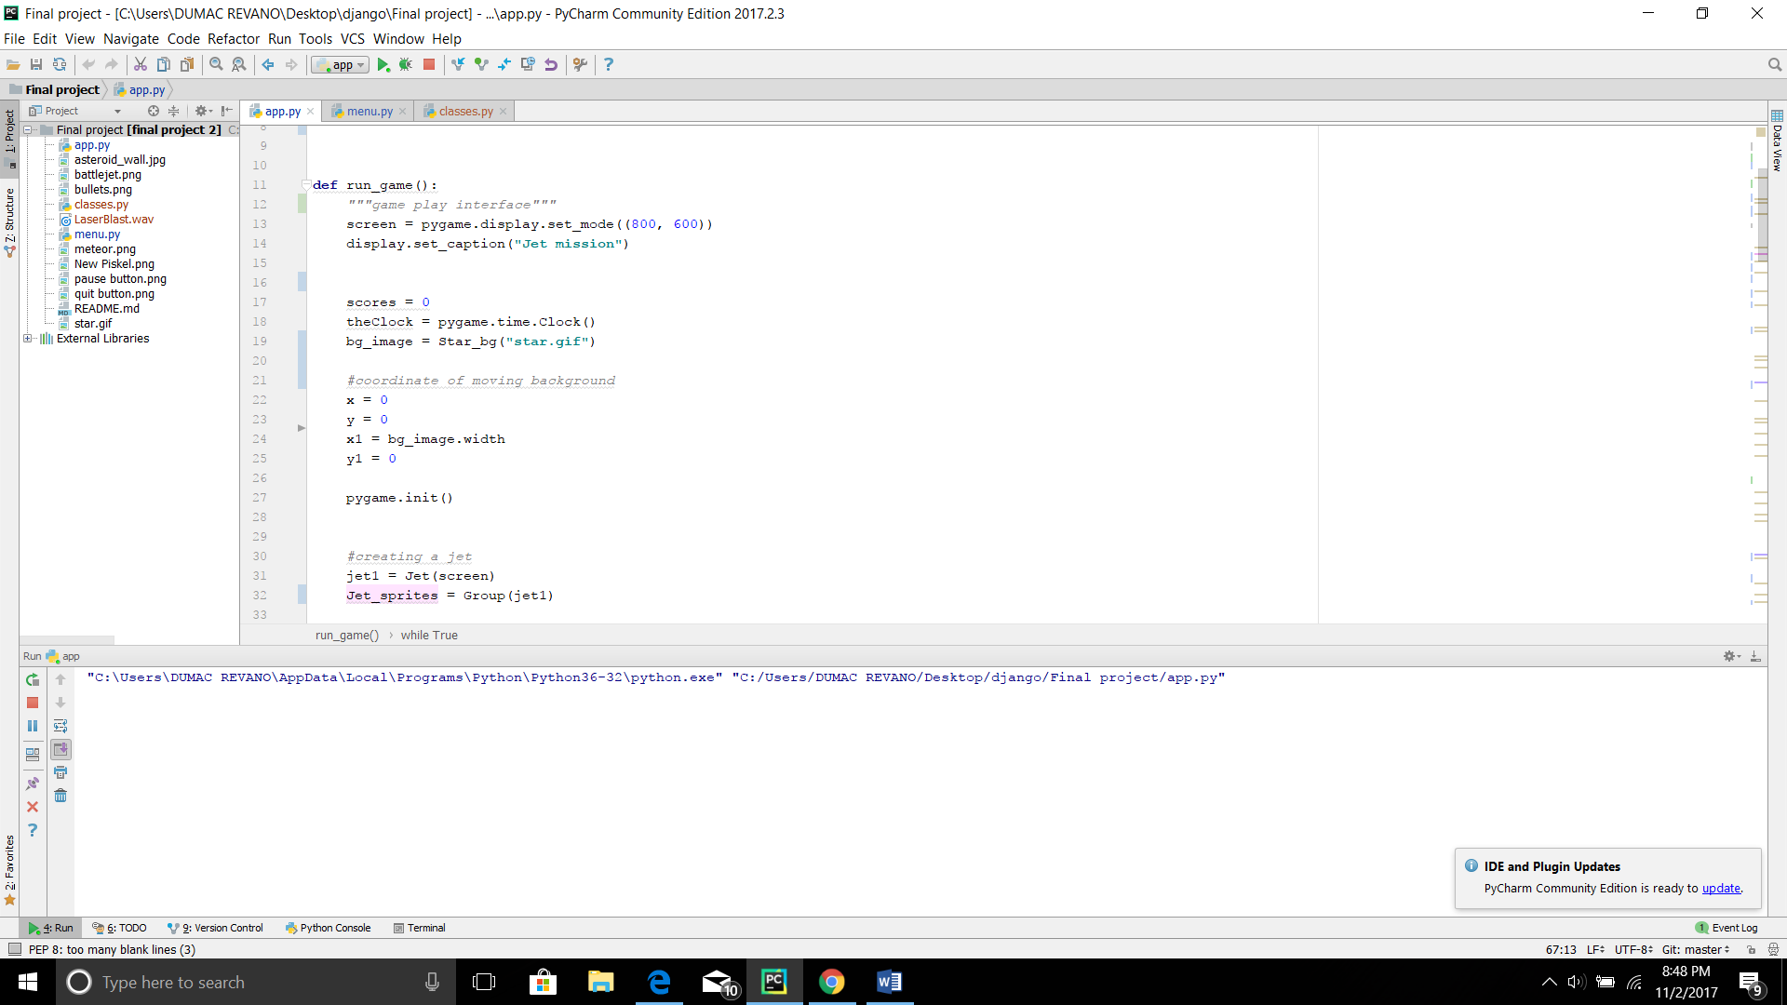

Example of jet method usage:

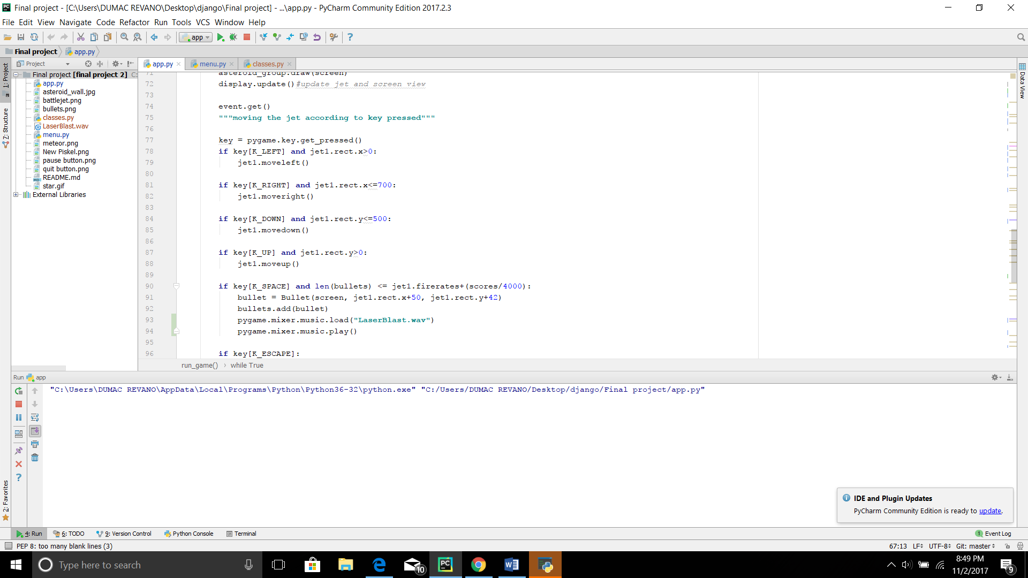

**Star_bg Class**

This “Star_bg” class is used as the base for the background in the whole game play, and it has a parameter background which affect the image displayed. This class has a method called as draw which will draw the background image too the screen. There are three parameters inside the draw method, screen parameter will decide on which surface the image will be drawn, x and y decide the coordinate position of the image.

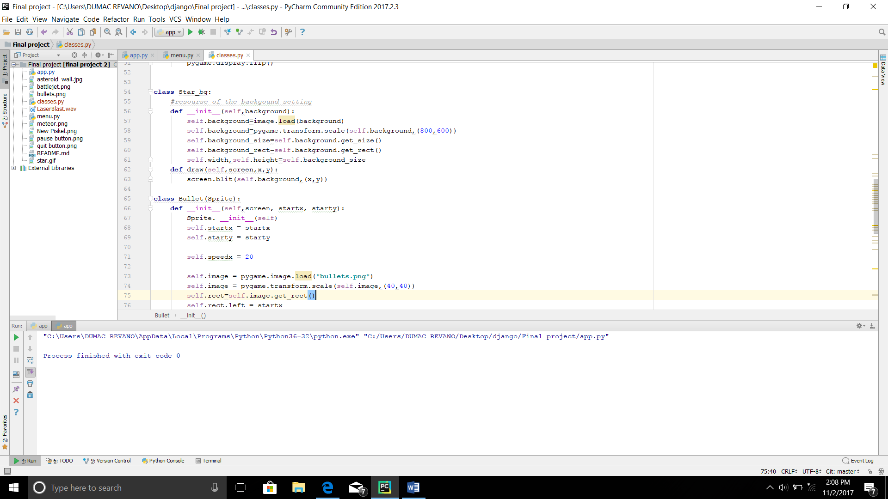

Example of the star_bg class usage:

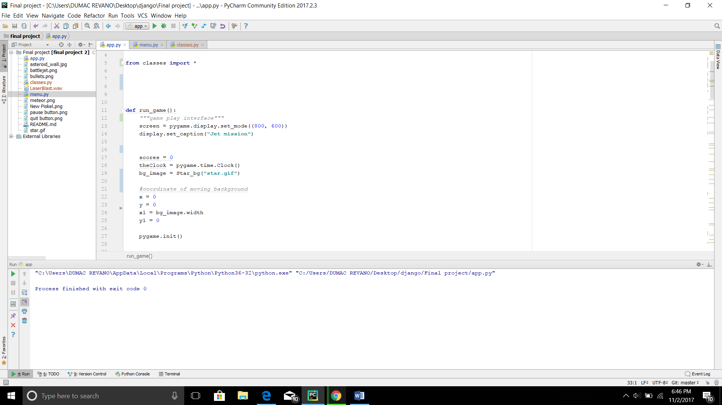

Example of the star_bg’s draw method usage:

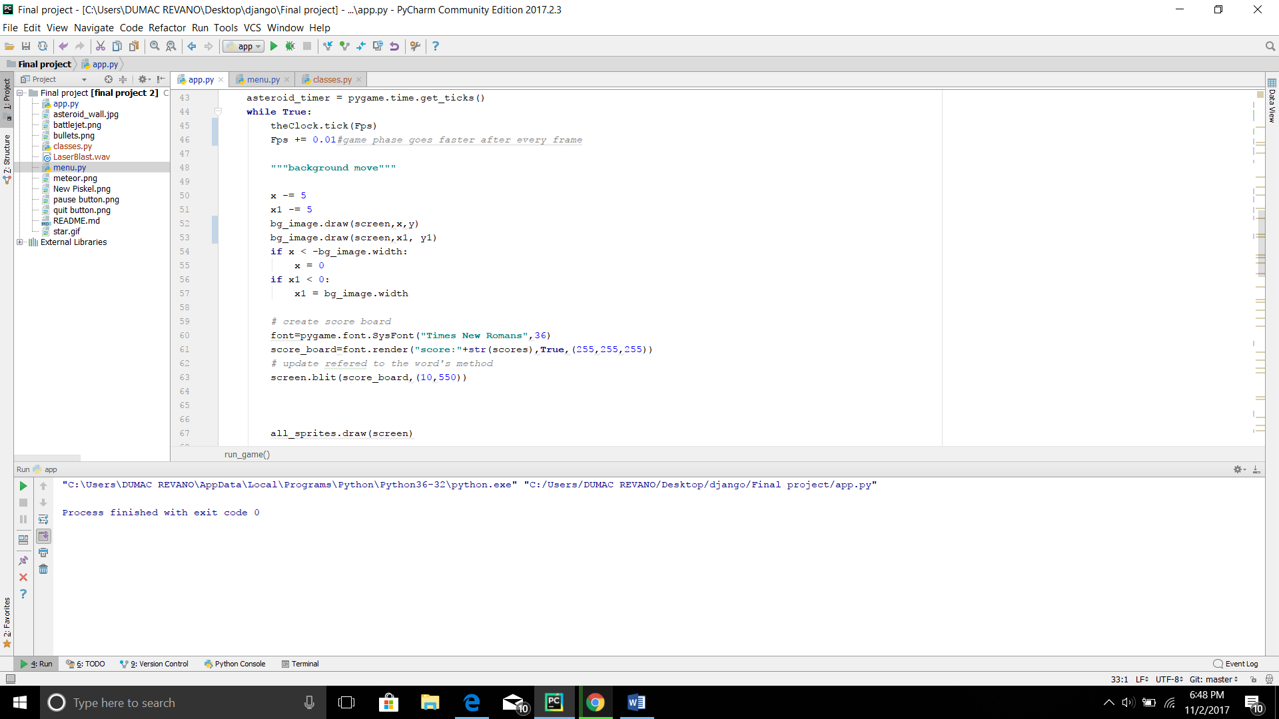

Bullet Class

This bullet class is used as the base of the bullet that is shot from the jet itself. This class has attribute to control the image, rectangle, surface, speed and almost anything related to bullets behavior. The parameter screen decides on which surface the bullet will be drawn, while startx and starty parameter decide the coordinate position where the bullet appear for the first time after it is called. This class also consist of method which will move the bullet’s position like how a bullet used to move. Besides this class inherited the Sprite so it can use any method on the Sprites.

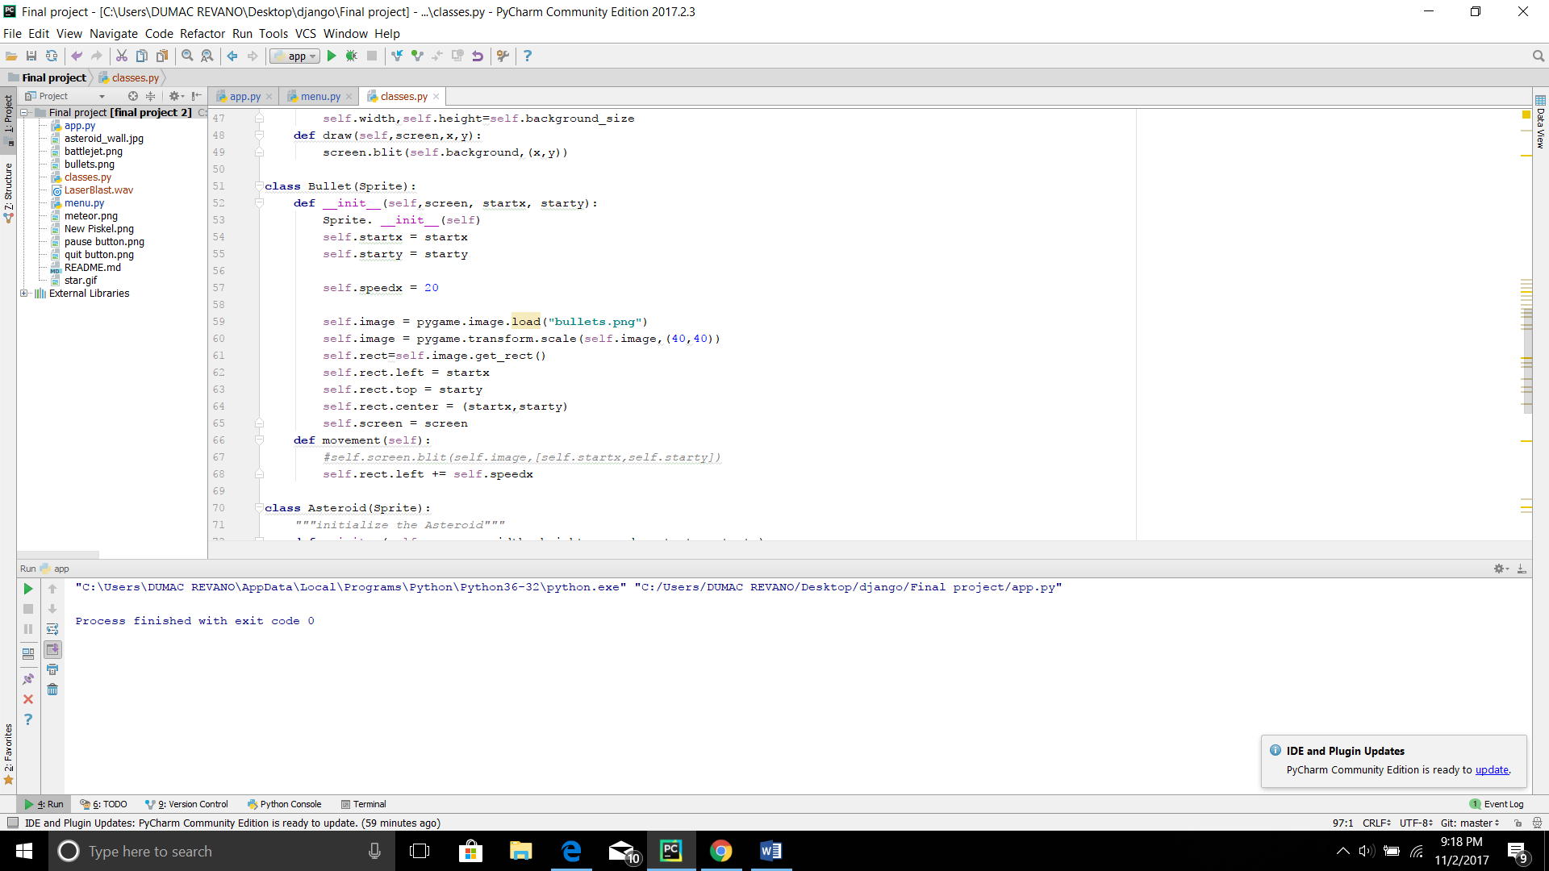

Example of bullet class usage:

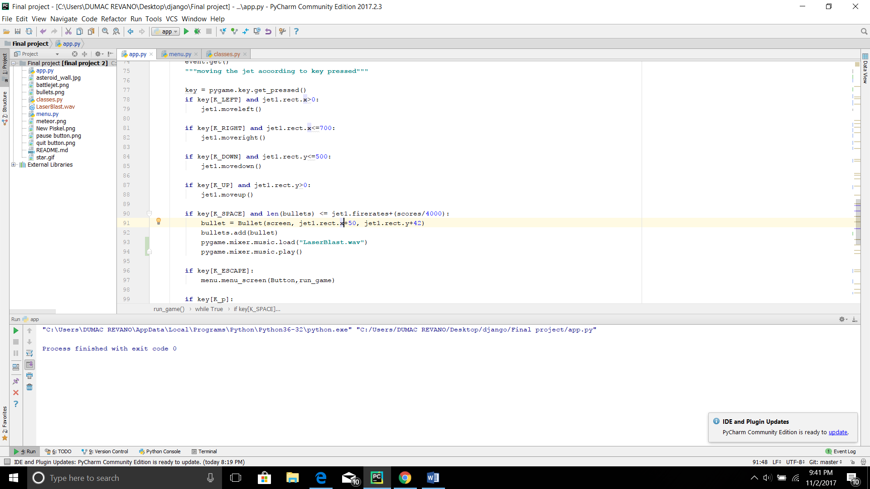

Asteroid Class

Asteroid Class Basically has the same concept with the bullet class, however instead of having a fixed speed Asteroid speed is determined by a parameter.

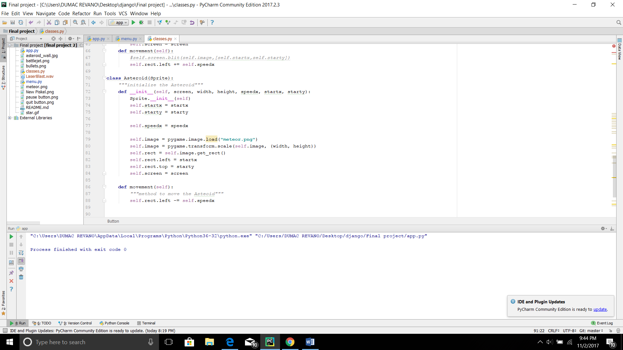

Example of Asteroid class usage:

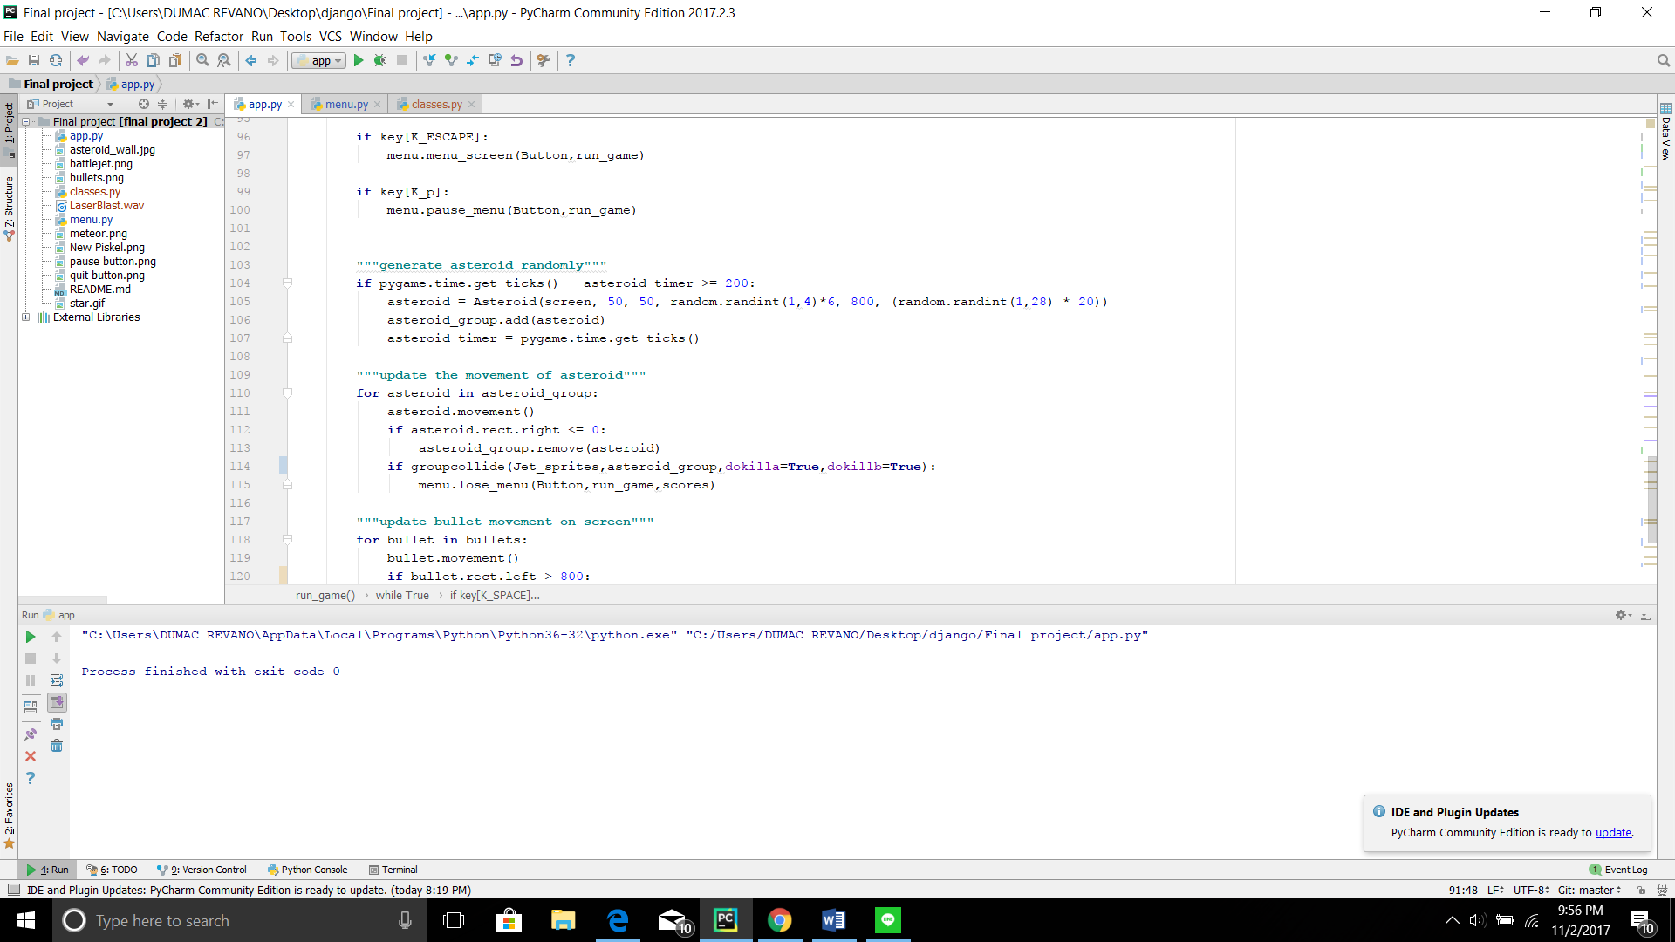

**Button class**

This class is used as the base to insert the button image in the game menu, the image parameter decide which image will be used as the image of the button.

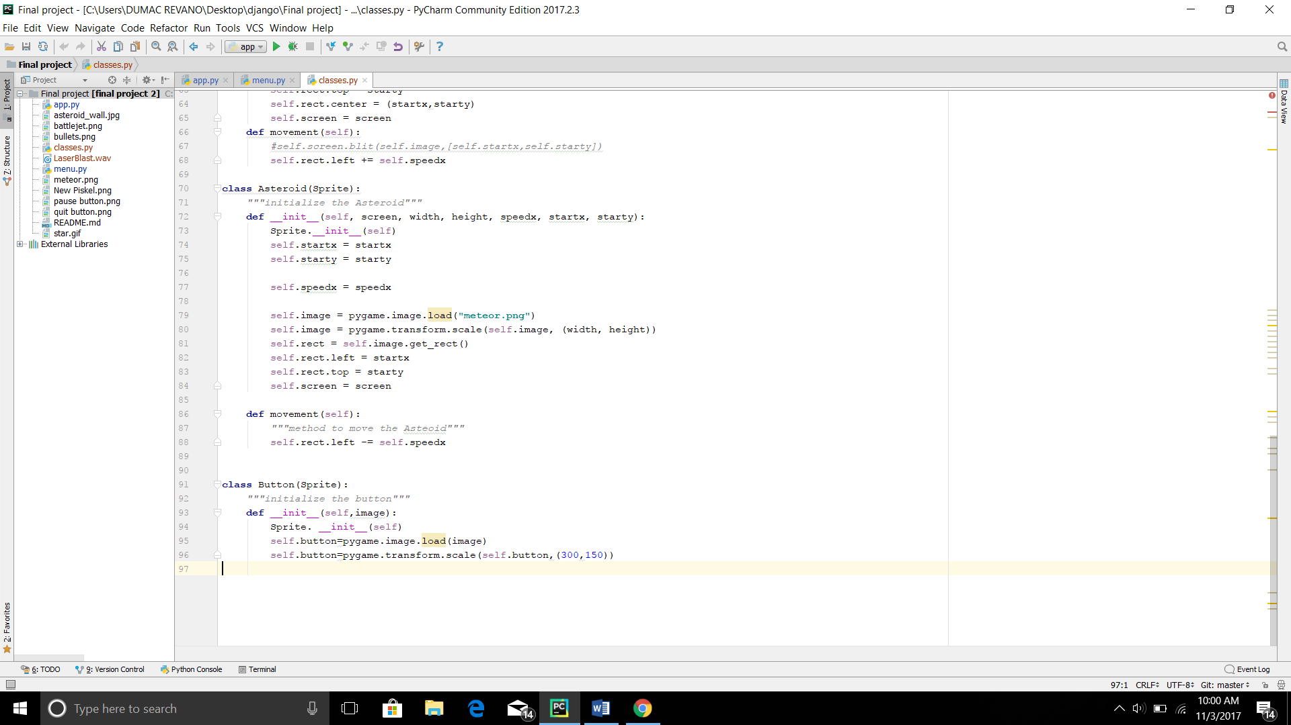

Example of button class usage in the menu:

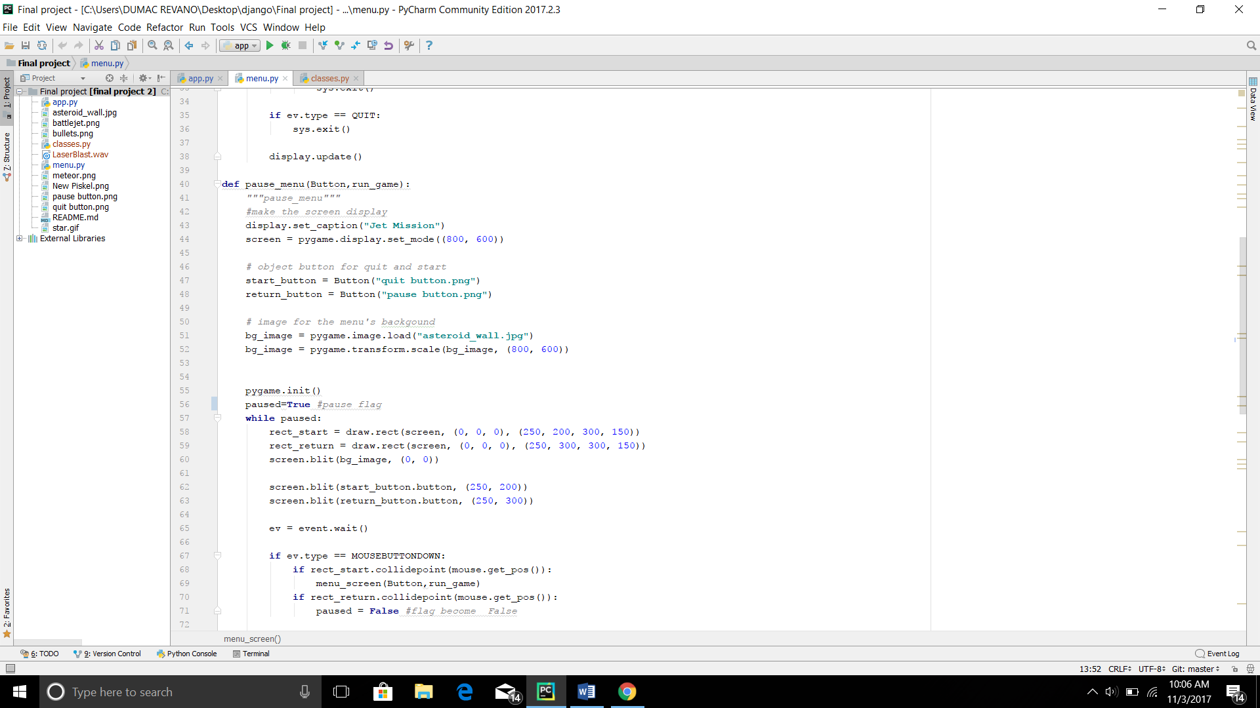

This file includes of some custom build function that specialized on displaying menu interface. To help the menu function some outside library like sys also imported. Here are the explanation of the each function contained in the menu.py.

**menu_screen function**

This function is used to make the first menu which player will encounter after the game run. This function also has two parameters with it, Button parameter is a parameter which must be filled with class name which will determine the button displayed in the screen, while run_game button will decide what action will be done after specified user event detected.

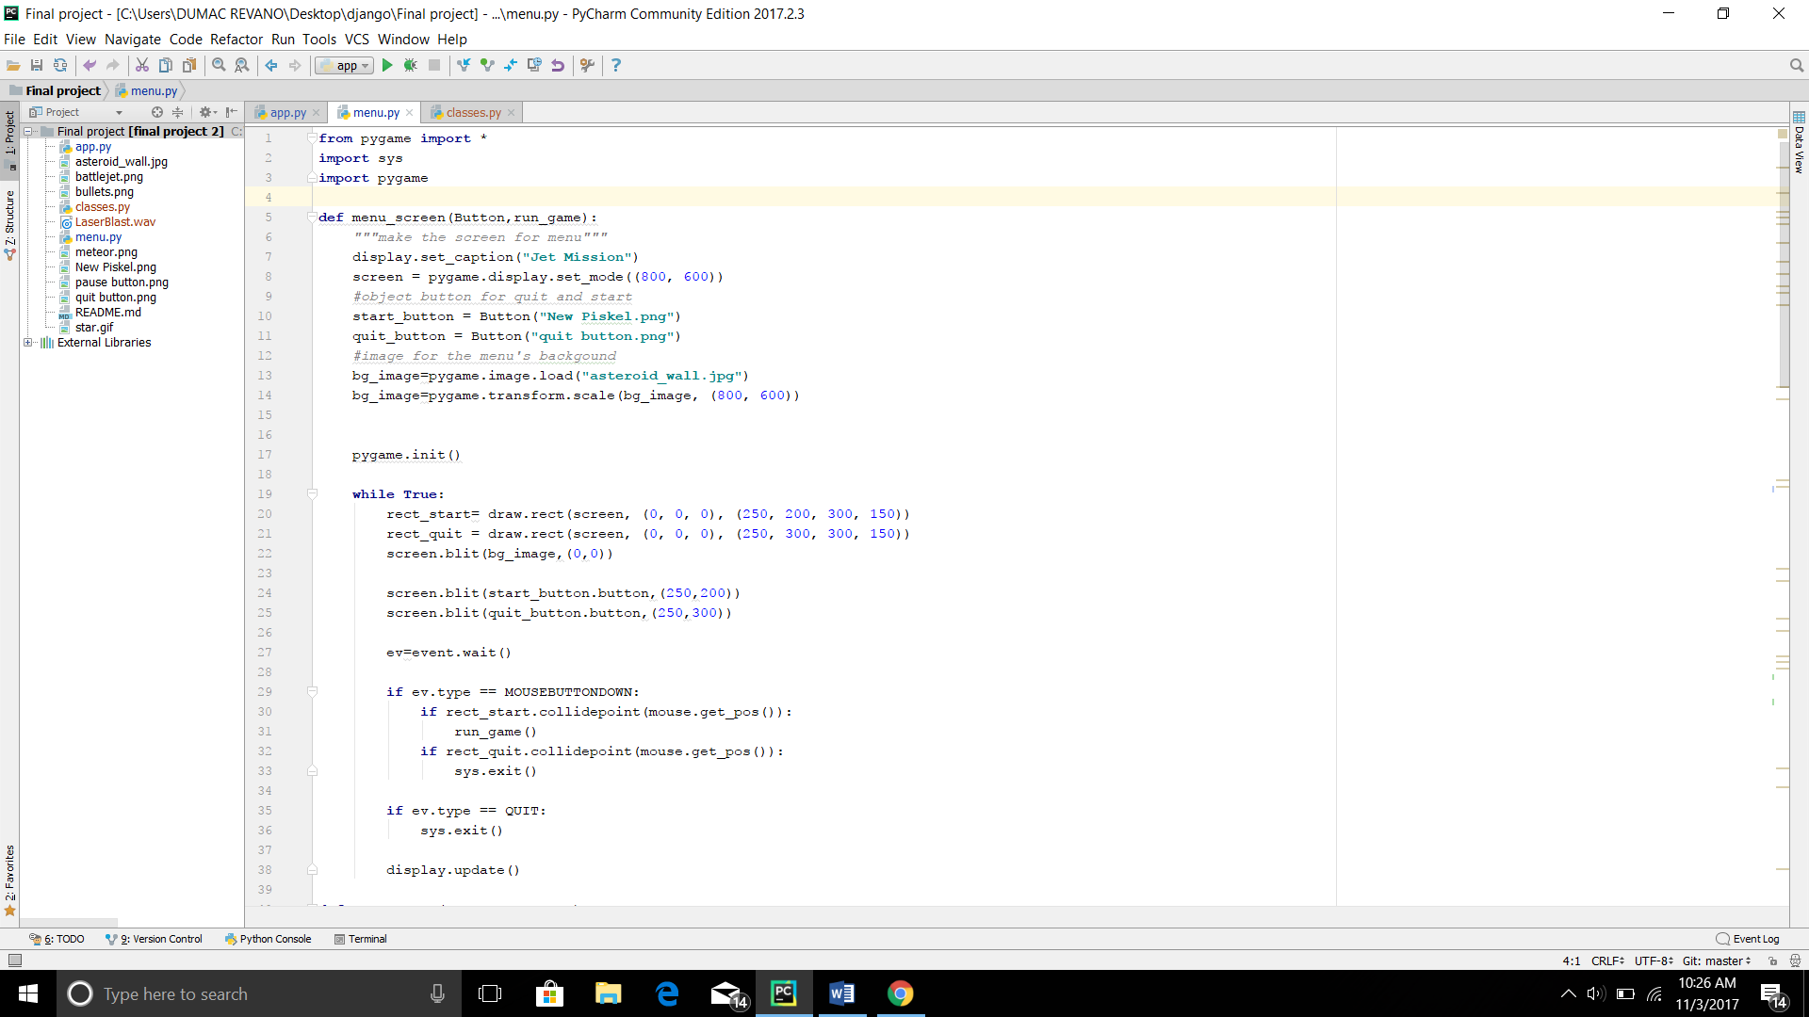



Example of called menu_screen function:

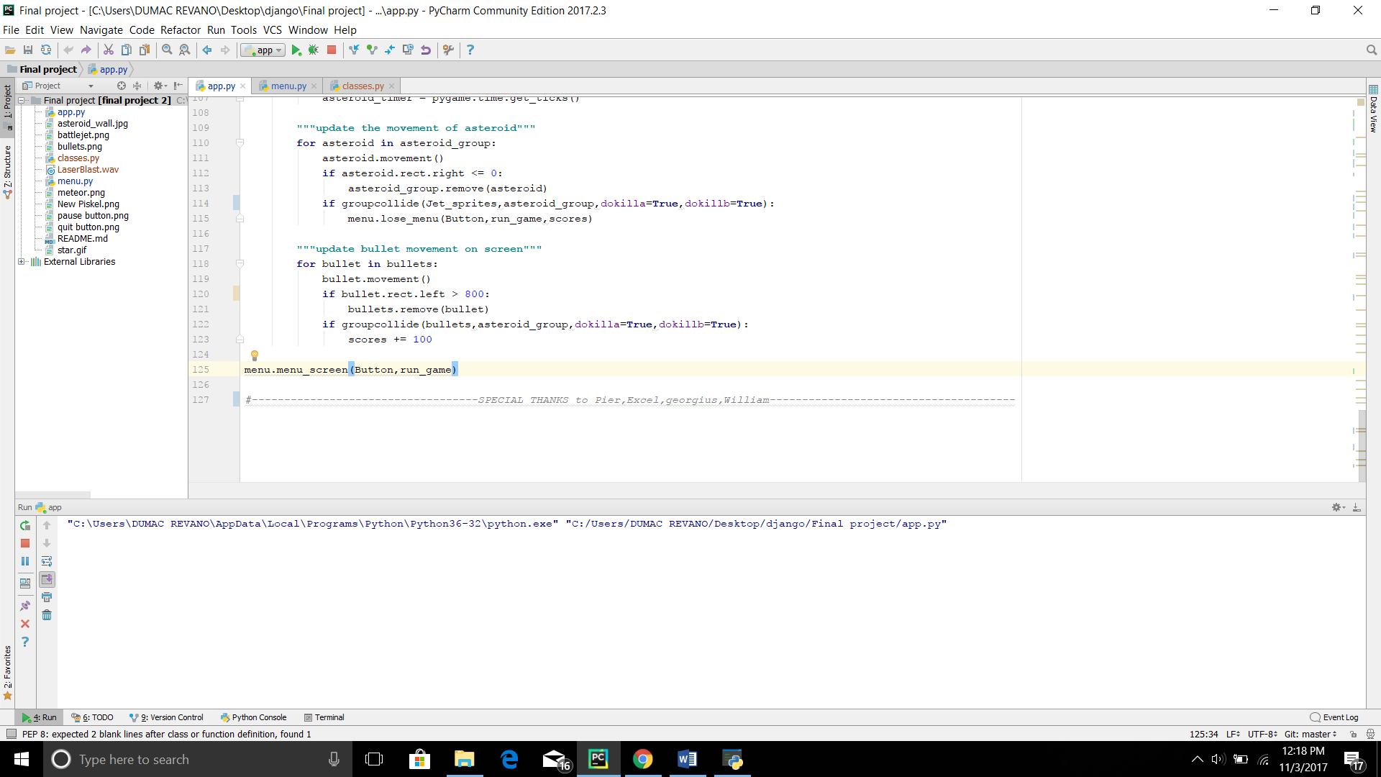

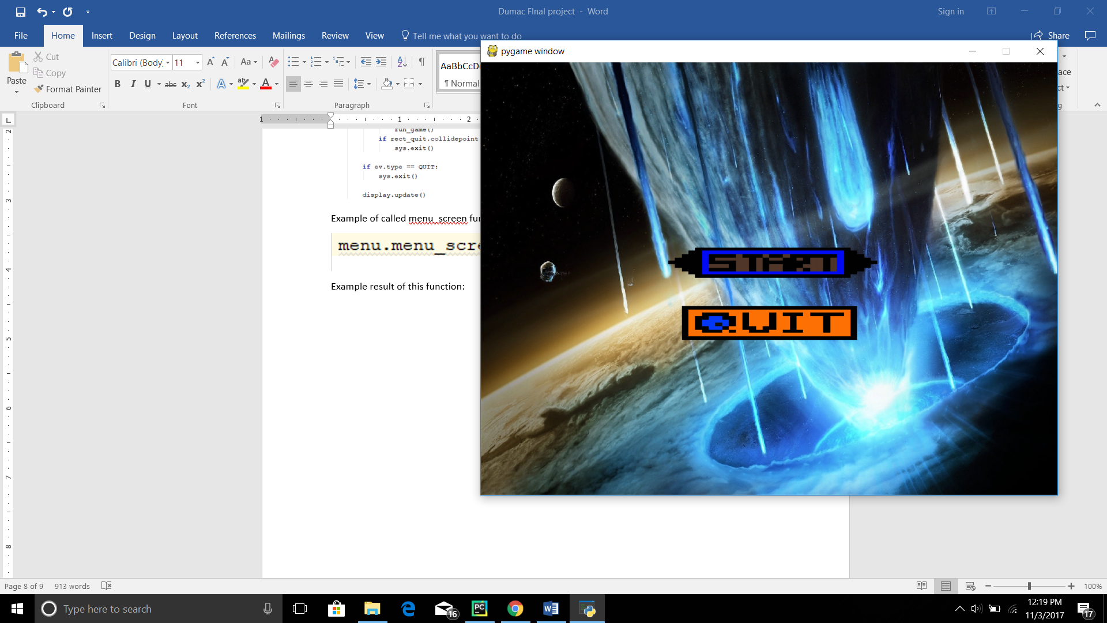when code is executed window like below will appear on the screen

lose_menu function

this function is a function that is used to create the losing menu, just like the menu_screen this menu consists of display set which is part of pygame library. Though it is almost the same with the menu_screen function this menu has a parameter called score, this parameter will be filled with an interger variable. This interger variable will then be drawn onto the screen as final results.

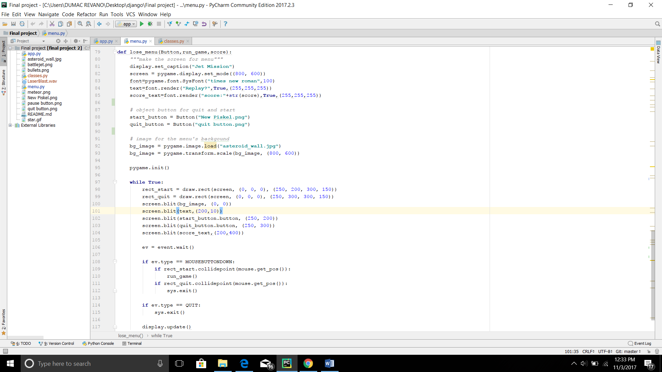

Example of called lose_menu function:

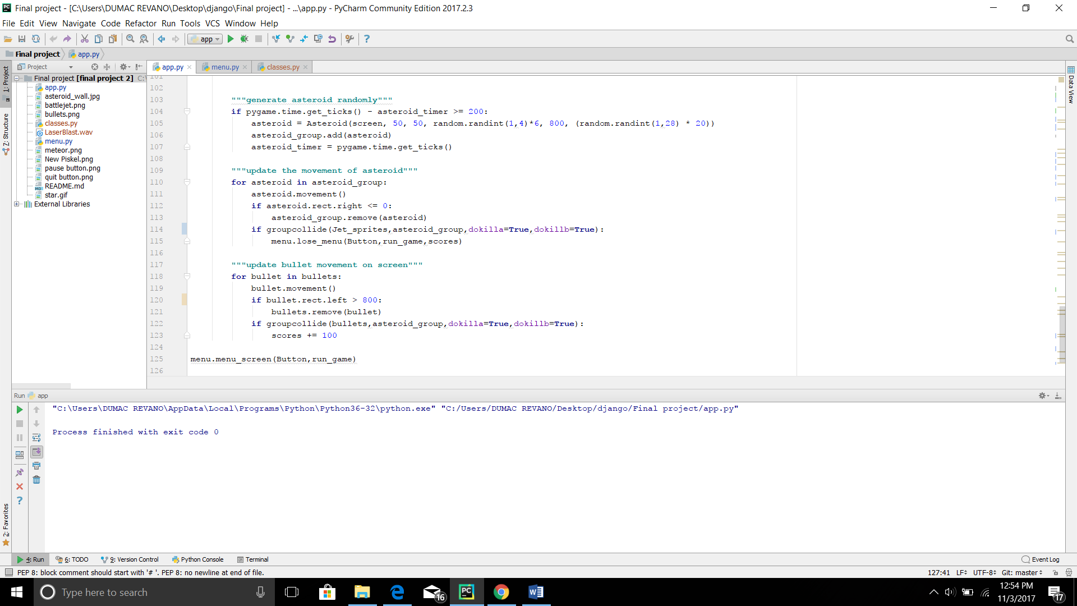

If this function is triggered a window similar with the picture below will be shown:

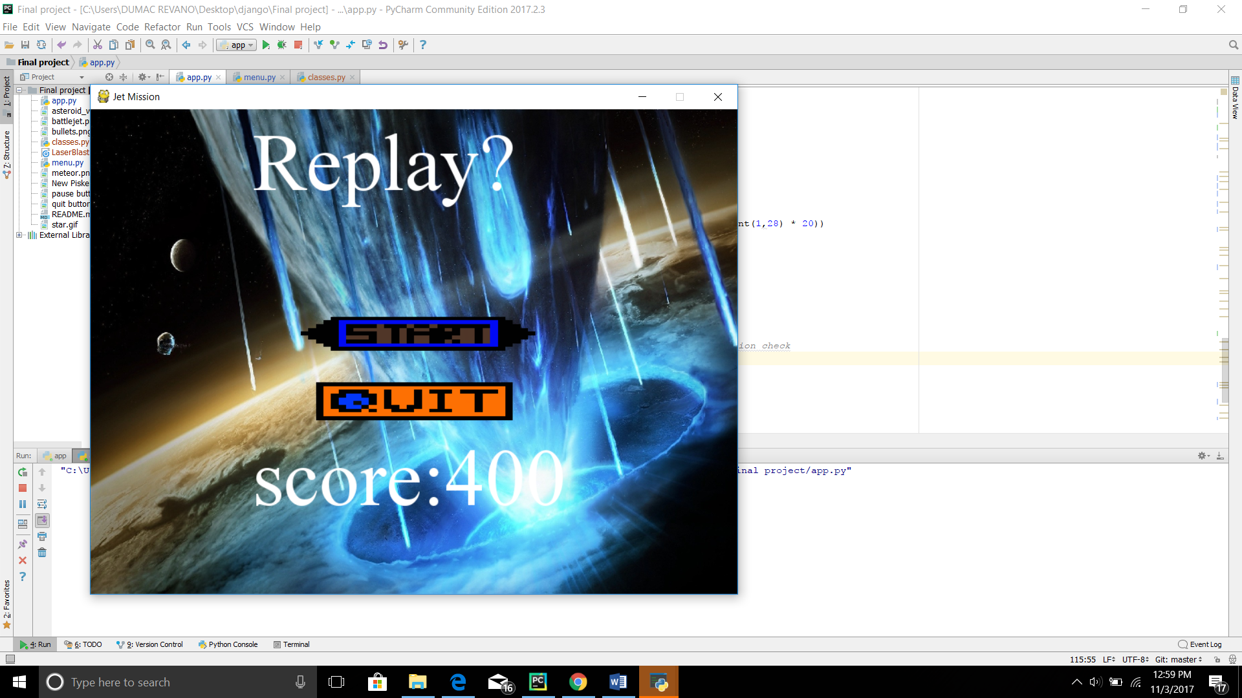

Pause_menu function

Theoretically this function work just like two menu’s functions before. However at here to trigger the program, flagging is used in order to close the program, so that it didn’t affect the main game.

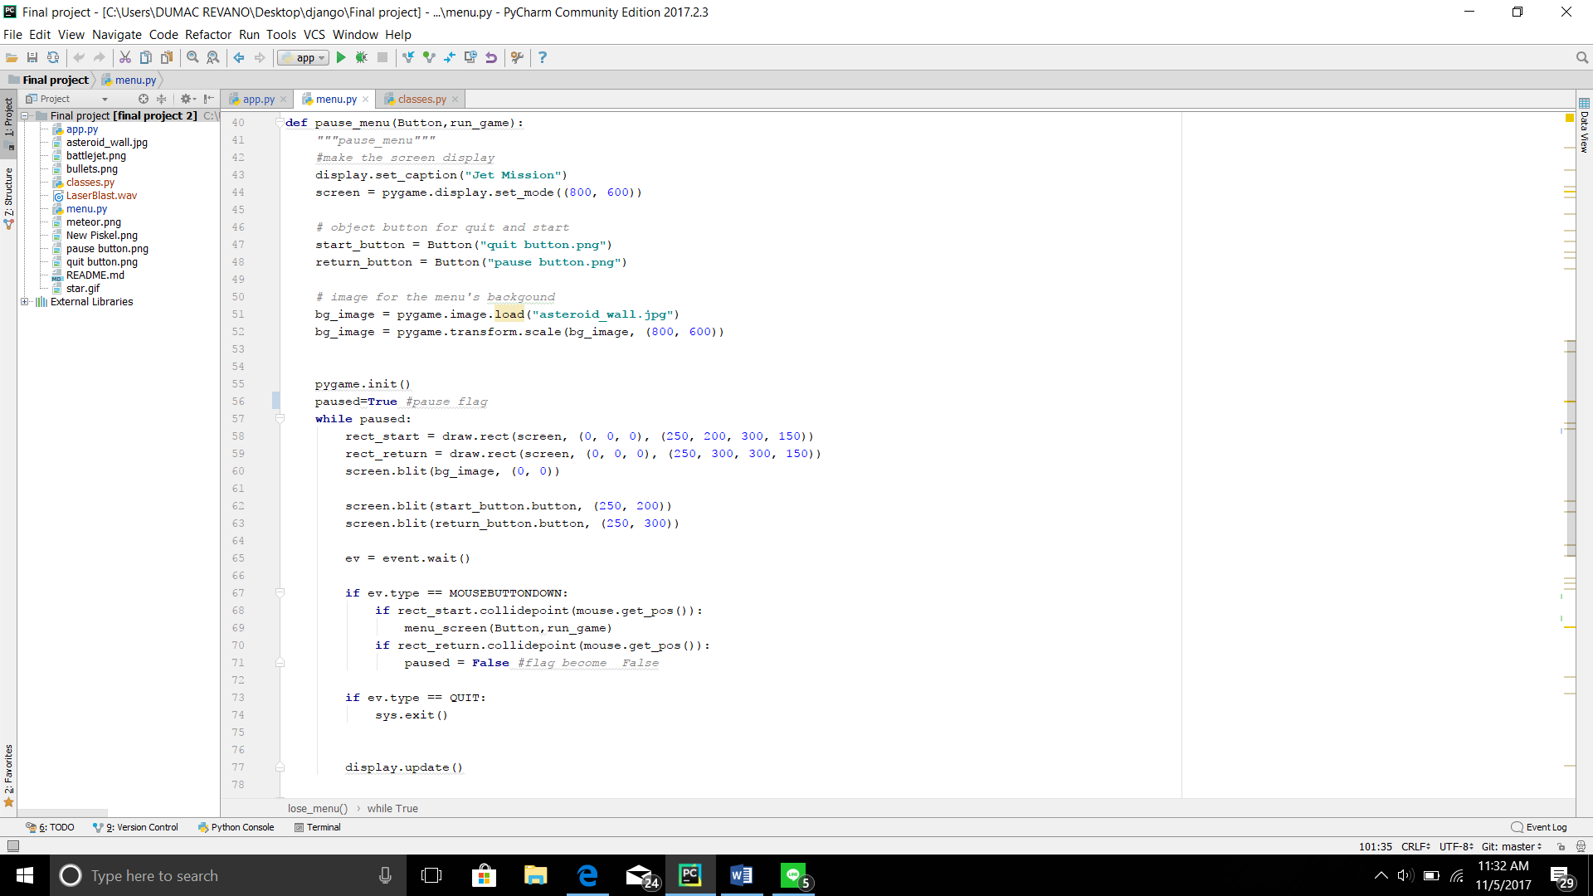



The example of pause_menu called function:

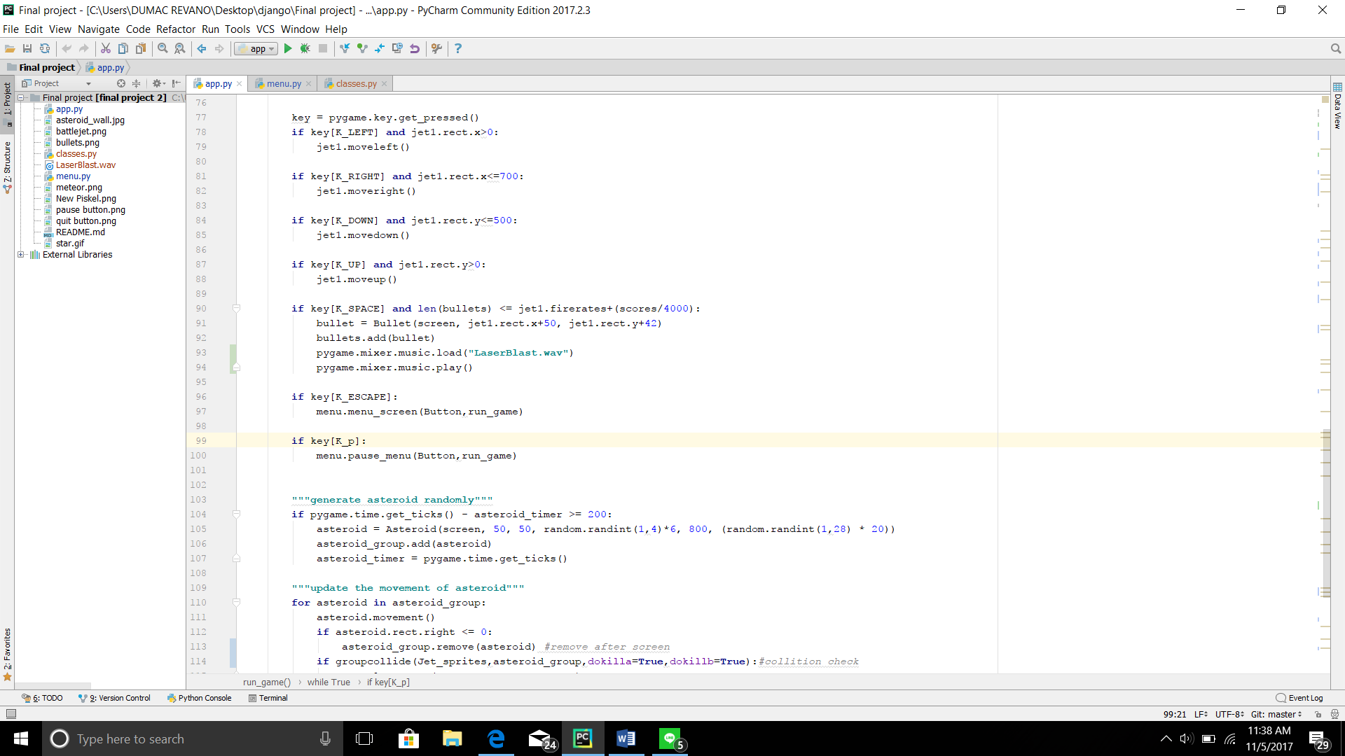

When this code is executed windows similar with below image will appear:

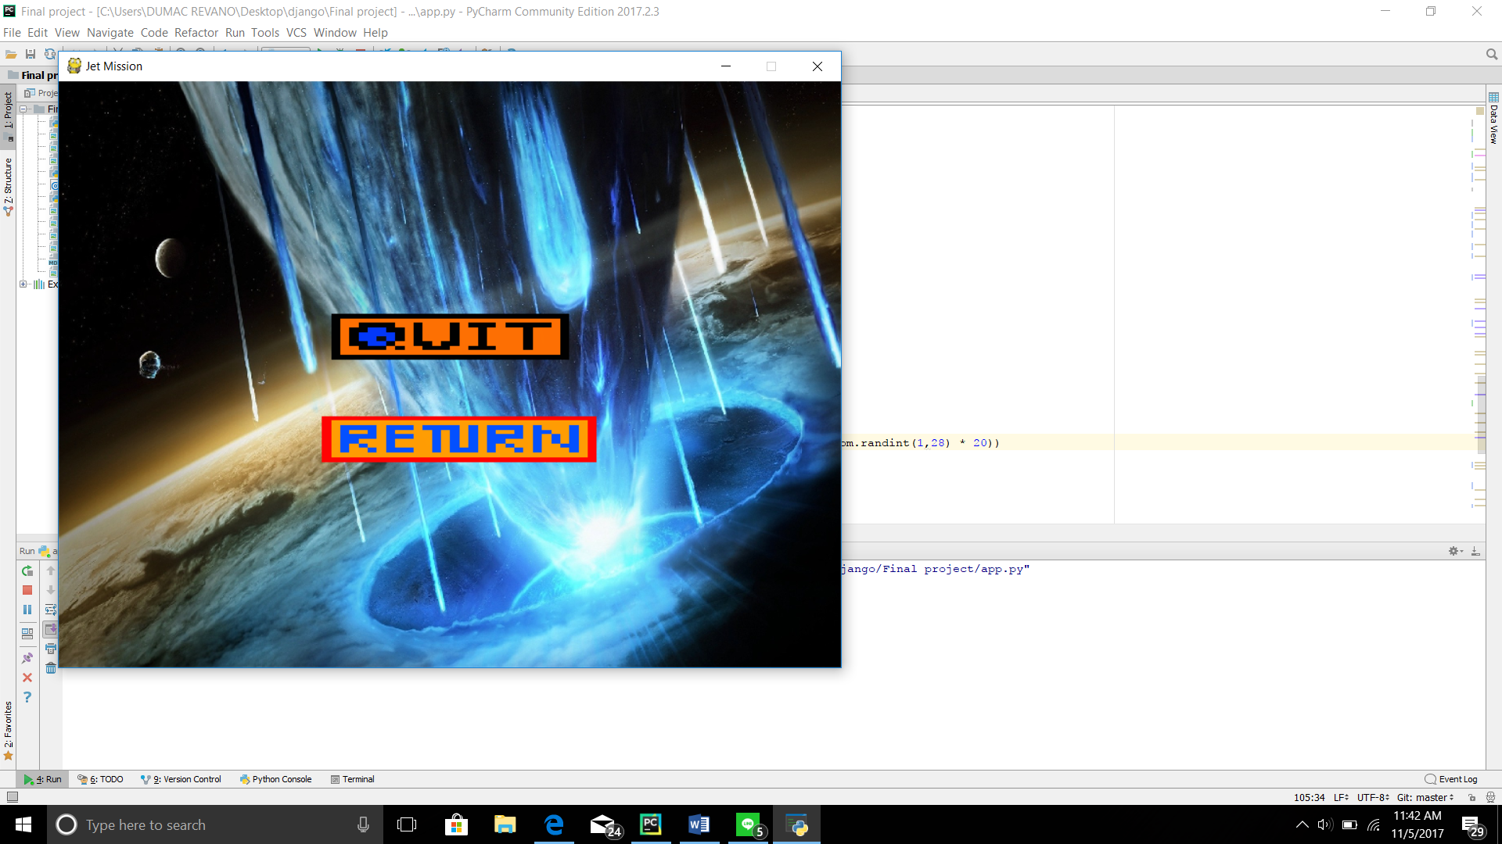

**App.py**

This python file consists only of one function, the run_game function. The run_game function control everything in the main game play. This function affect the moving background in the game, collide check amongst sprite,scoring, ext.

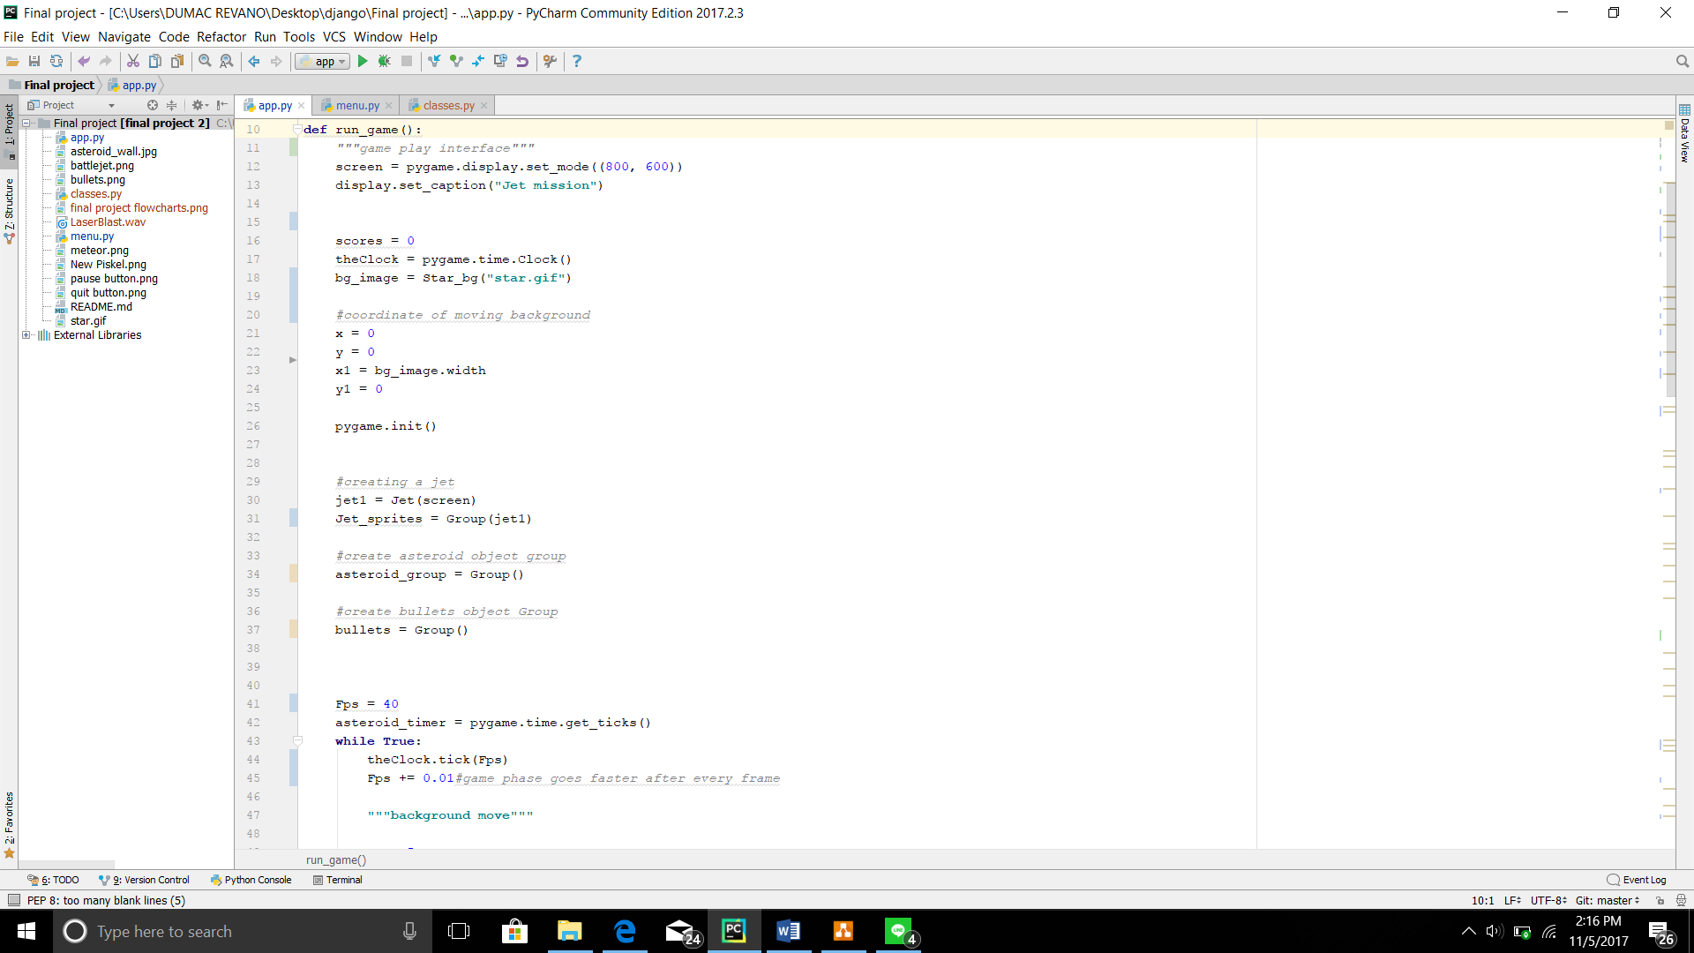

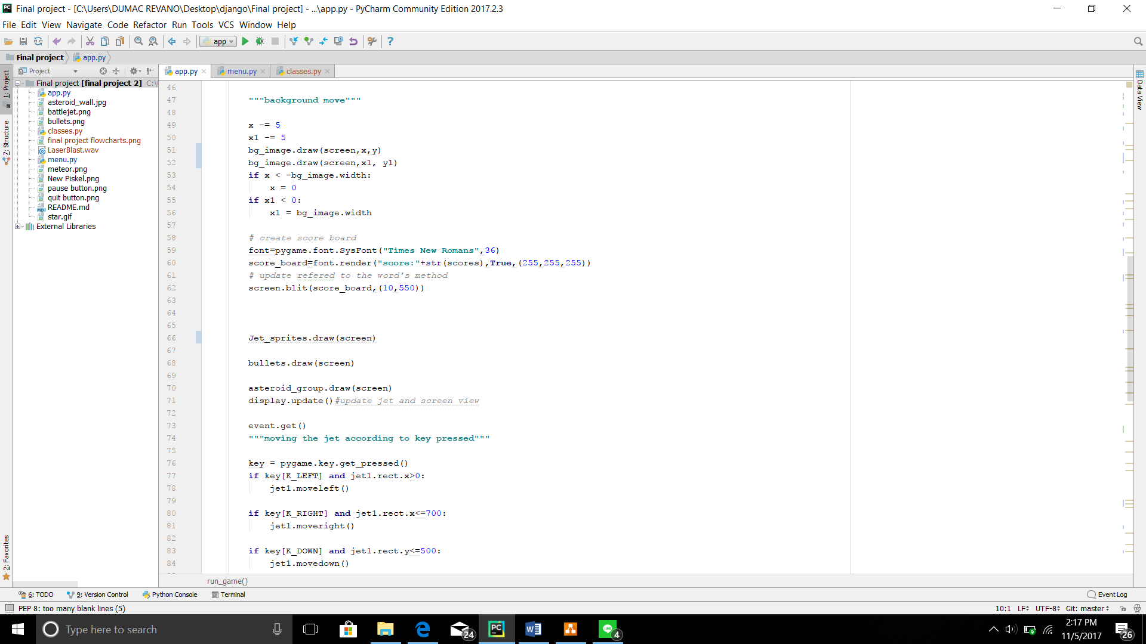

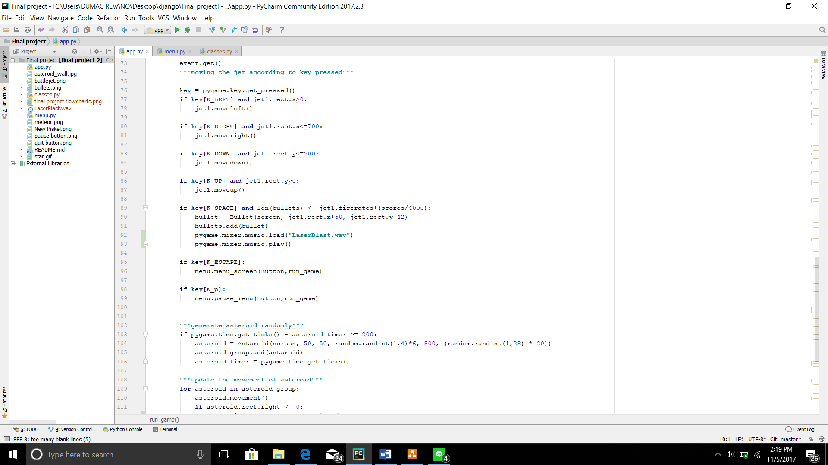

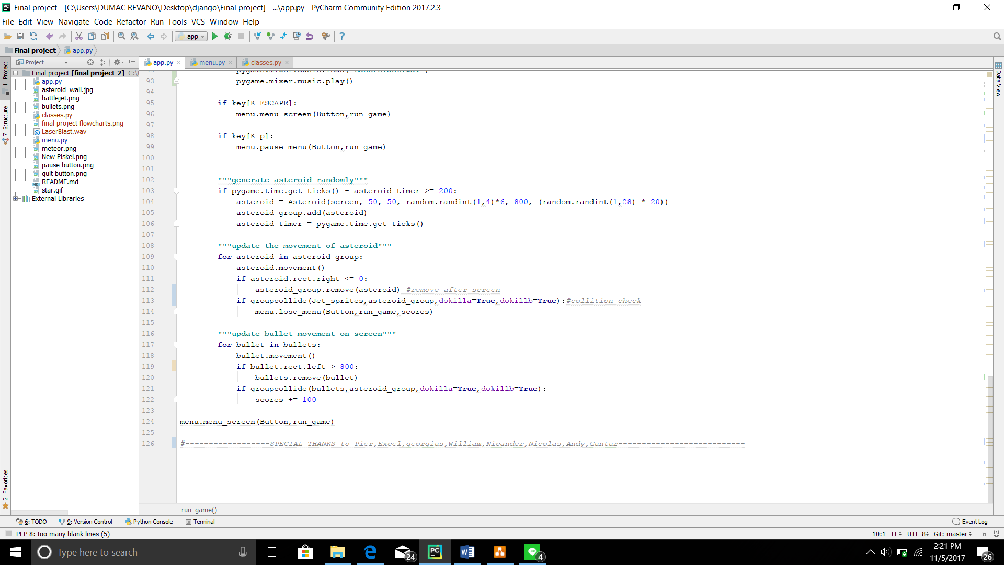

When this code is executed it will show the game play:

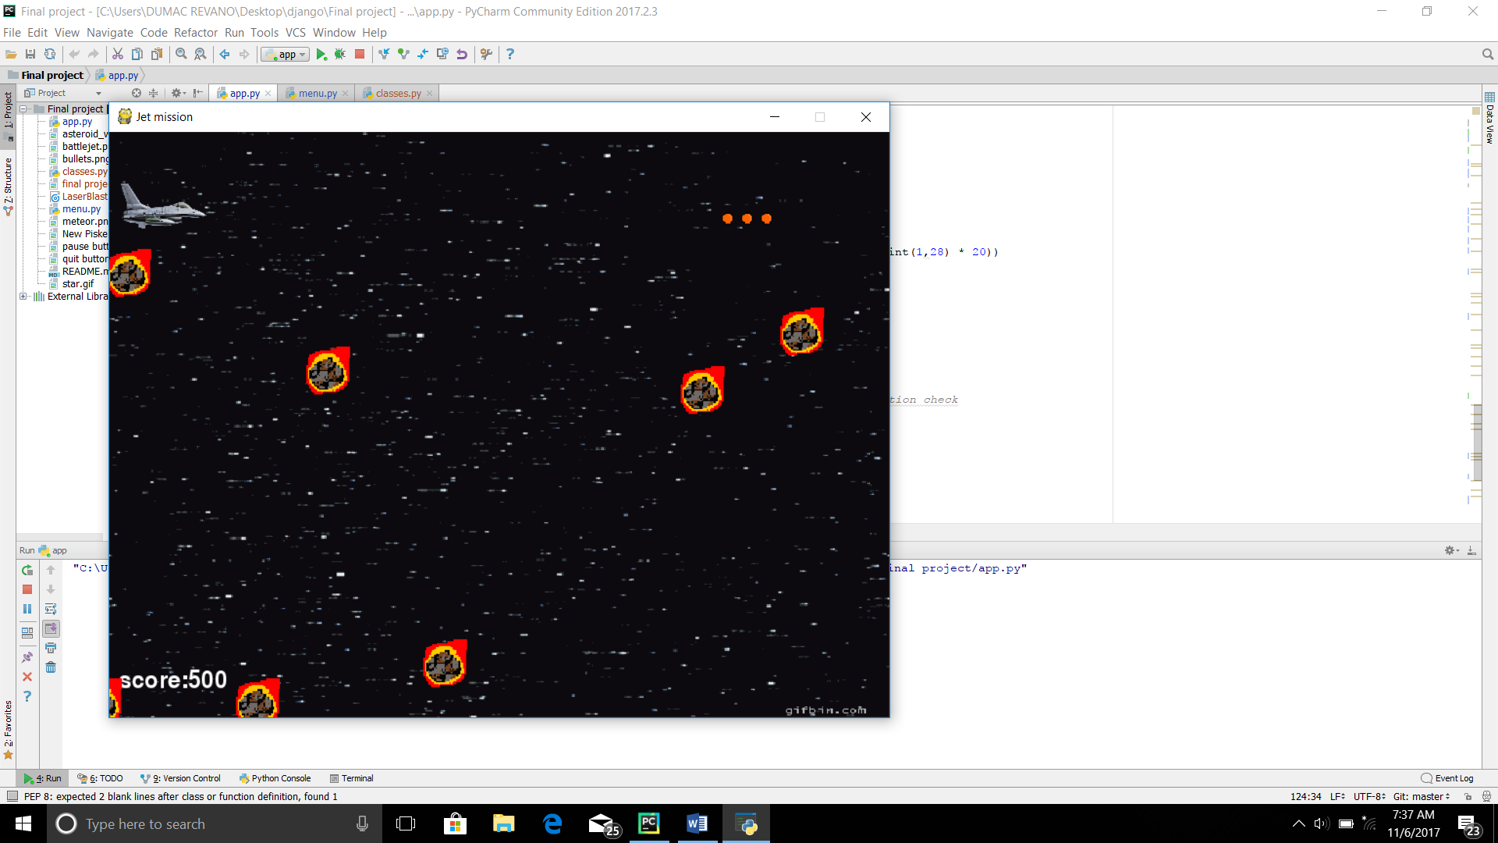

1. **Game’s flowchart**

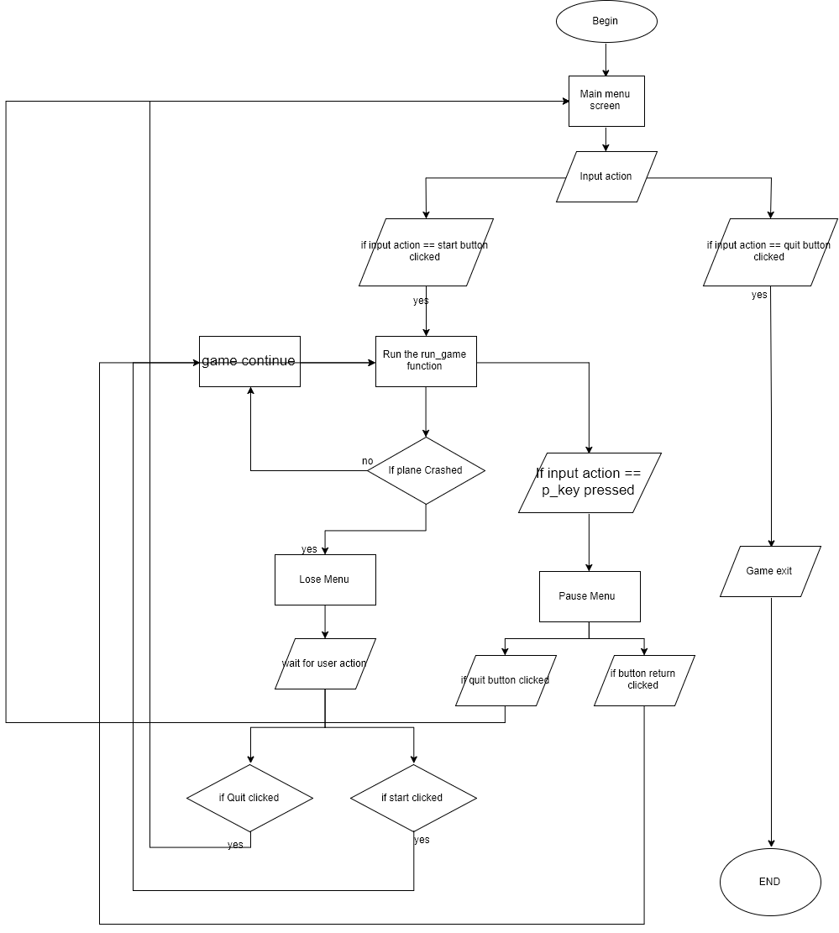

1. **Class diagram**

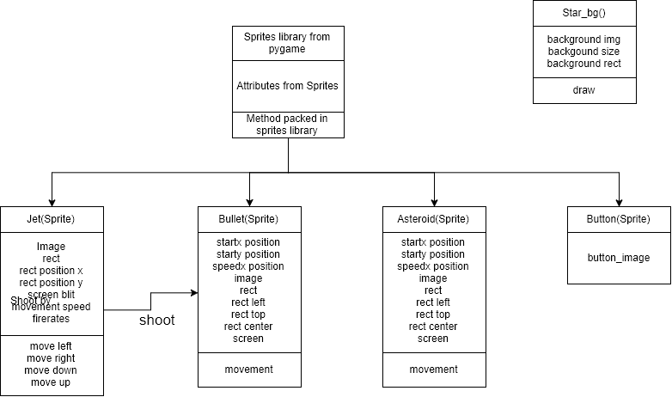

1. **Source Code**

Classes.py

**from** pygame **import** *  
**from** pygame.sprite **import** *  
  
**class** Jet(Sprite):  
 *"""initialize the jet"""* **def** __init__(self, screen):  
 Sprite.__init__(self)  
 **"""initialize the Jet"""** self.image = image.load(**"battlejet.png"**)  
 self.image = pygame.transform.scale(self.image, (90, 50))  
 self.rect = self.image.get_rect()  
 self.rect.x = 10  
 self.rect.y = 50  
 self.screen = screen  
 self.move_speed = 6  
 **"""bullet"""** self.firerates = 2  
  
 **def** moveleft(self):  
 self.rect.x -= self.move_speed  
 display.flip()  
  
 **def** moveright(self):  
 self.rect.x += self.move_speed  
 display.flip()  
  
 **def** moveup(self):  
 self.rect.y -= self.move_speed  
 display.flip()  
  
 **def** movedown(self):  
 self.rect.y += self.move_speed  
 display.flip()  
  
  
  
  
  
**class** Star_bg:  
 *#resourse of the backgound setting* **def** __init__(self,background):  
 self.background=image.load(background)  
 self.background=pygame.transform.scale(self.background,(800,600))  
 self.background_size=self.background.get_size()  
 self.background_rect=self.background.get_rect()  
 self.width,self.height=self.background_size  
 **def** draw(self,screen,x,y):  
 screen.blit(self.background,(x,y))  
  
**class** Bullet(Sprite):  
 **def** __init__(self,screen, startx, starty):  
 Sprite. __init__(self)  
 self.startx = startx  
 self.starty = starty  
  
 self.speedx = 20  
  
 self.image = pygame.image.load(**"bullets.png"**)  
 self.image = pygame.transform.scale(self.image,(40,40))  
 self.rect=self.image.get_rect()  
 self.rect.left = startx  
 self.rect.top = starty  
 self.rect.center = (startx,starty)  
 self.screen = screen  
 **def** movement(self):  
 *#self.screen.blit(self.image,[self.startx,self.starty])* self.rect.left += self.speedx  
  
**class** Asteroid(Sprite):  
 *"""initialize the Asteroid"""* **def** __init__(self, screen, width, height, speedx, startx, starty):  
 Sprite.__init__(self)  
 self.startx = startx  
 self.starty = starty  
  
 self.speedx = speedx  
  
 self.image = pygame.image.load(**"meteor.png"**)  
 self.image = pygame.transform.scale(self.image, (width, height))  
 self.rect = self.image.get_rect()  
 self.rect.left = startx  
 self.rect.top = starty  
 self.screen = screen  
  
 **def** movement(self):  
 *"""method to move the Asteoid"""* self.rect.left -= self.speedx  
  
  
**class** Button(Sprite):  
 *"""initialize the button"""* **def** __init__(self,image):  
 Sprite. __init__(self)  
 self.button=pygame.image.load(image)  
 self.button=pygame.transform.scale(self.button,(300,150))

Menu.py

**from** pygame **import** *  
**import** sys  
**import** pygame  
  
**def** menu_screen(Button,run_game):  
 *"""make the screen for menu"""* display.set_caption(**"Jet Mission"**)  
 screen = pygame.display.set_mode((800, 600))  
 *#object button for quit and start* start_button = Button(**"New Piskel.png"**)  
 quit_button = Button(**"quit button.png"**)  
 *#image for the menu's backgound* bg_image=pygame.image.load(**"asteroid_wall.jpg"**)  
 bg_image=pygame.transform.scale(bg_image, (800, 600))  
  
  
 pygame.init()  
  
 **while True**:  
 rect_start= draw.rect(screen, (0, 0, 0), (250, 200, 300, 150))  
 rect_quit = draw.rect(screen, (0, 0, 0), (250, 300, 300, 150))  
 screen.blit(bg_image,(0,0))  
  
 screen.blit(start_button.button,(250,200))  
 screen.blit(quit_button.button,(250,300))  
  
 ev=event.wait()  
  
 **if** ev.type == MOUSEBUTTONDOWN:  
 **if** rect_start.collidepoint(mouse.get_pos()):  
 run_game()  
 **if** rect_quit.collidepoint(mouse.get_pos()):  
 sys.exit()  
  
 **if** ev.type == QUIT:  
 sys.exit()  
  
 display.update()  
  
**def** pause_menu(Button,run_game):  
 *"""pause_menu"""  
 #make the screen display* display.set_caption(**"Jet Mission"**)  
 screen = pygame.display.set_mode((800, 600))  
  
 *# object button for quit and start* start_button = Button(**"quit button.png"**)  
 return_button = Button(**"pause button.png"**)  
  
 *# image for the menu's backgound* bg_image = pygame.image.load(**"asteroid_wall.jpg"**)  
 bg_image = pygame.transform.scale(bg_image, (800, 600))  
  
  
 pygame.init()  
 paused=**True** *#pause flag* **while** paused:  
 rect_start = draw.rect(screen, (0, 0, 0), (250, 200, 300, 150))  
 rect_return = draw.rect(screen, (0, 0, 0), (250, 300, 300, 150))  
 screen.blit(bg_image, (0, 0))  
  
 screen.blit(start_button.button, (250, 200))  
 screen.blit(return_button.button, (250, 300))  
  
 ev = event.wait()  
  
 **if** ev.type == MOUSEBUTTONDOWN:  
 **if** rect_start.collidepoint(mouse.get_pos()):  
 menu_screen(Button,run_game)  
 **if** rect_return.collidepoint(mouse.get_pos()):  
 paused = **False** *#flag become False* **if** ev.type == QUIT:  
 sys.exit()  
  
  
 display.update()  
  
**def** lose_menu(Button,run_game,score):  
 *"""make the screen for menu"""* display.set_caption(**"Jet Mission"**)  
 screen = pygame.display.set_mode((800, 600))  
 font=pygame.font.SysFont(**"times new roman"**,100)  
 text=font.render(**"Replay?"**,**True**,(255,255,255))  
 score_text=font.render(**"score:"**+str(score),**True**,(255,255,255))  
  
 *# object button for quit and start* start_button = Button(**"New Piskel.png"**)  
 quit_button = Button(**"quit button.png"**)  
  
 *# image for the menu's backgound* bg_image = pygame.image.load(**"asteroid_wall.jpg"**)  
 bg_image = pygame.transform.scale(bg_image, (800, 600))  
  
 pygame.init()  
  
 **while True**:  
 rect_start = draw.rect(screen, (0, 0, 0), (250, 200, 300, 150))  
 rect_quit = draw.rect(screen, (0, 0, 0), (250, 300, 300, 150))  
 screen.blit(bg_image, (0, 0))  
 screen.blit(text,(200,10))  
 screen.blit(start_button.button, (250, 200))  
 screen.blit(quit_button.button, (250, 300))  
 screen.blit(score_text,(200,400))  
  
 ev = event.wait()  
  
 **if** ev.type == MOUSEBUTTONDOWN:  
 **if** rect_start.collidepoint(mouse.get_pos()):  
 run_game()  
 **if** rect_quit.collidepoint(mouse.get_pos()):  
 sys.exit()  
  
 **if** ev.type == QUIT:  
 sys.exit()  
  
 display.update()

App.py

**from** pygame **import** *  
**import** menu  
**import** random  
  
**from** classes **import** *  
  
  
  
  
**def** run_game():  
 *"""game play interface"""* screen = pygame.display.set_mode((800, 600))  
 display.set_caption(**"Jet mission"**)  
  
  
 scores = 0  
 theClock = pygame.time.Clock()  
 bg_image = Star_bg(**"star.gif"**)  
  
 *#coordinate of moving background* x = 0  
 y = 0  
 x1 = bg_image.width  
 y1 = 0  
  
 pygame.init()  
  
  
 *#creating a jet* jet1 = Jet(screen)  
 Jet_sprites = Group(jet1)  
  
 *#create asteroid object group* asteroid_group = Group()  
  
 *#create bullets object Group* bullets = Group()  
  
  
  
 Fps = 40  
 asteroid_timer = pygame.time.get_ticks()  
 **while True**:  
 theClock.tick(Fps)  
 Fps += 0.01*#game phase goes faster after every frame* **"""background move"""** x -= 5  
 x1 -= 5  
 bg_image.draw(screen,x,y)  
 bg_image.draw(screen,x1, y1)  
 **if** x < -bg_image.width:  
 x = 0  
 **if** x1 < 0:  
 x1 = bg_image.width  
  
 *# create score board* font=pygame.font.SysFont(**"Times New Romans"**,36)  
 score_board=font.render(**"score:"**+str(scores),**True**,(255,255,255))  
 *# update refered to the word's method* screen.blit(score_board,(10,550))  
  
  
  
 Jet_sprites.draw(screen)  
  
 bullets.draw(screen)  
  
 asteroid_group.draw(screen)  
 display.update()*#update jet and screen view* event.get()  
 **"""moving the jet according to key pressed"""** key = pygame.key.get_pressed()  
 **if** key[K_LEFT] **and** jet1.rect.x>0:  
 jet1.moveleft()  
  
 **if** key[K_RIGHT] **and** jet1.rect.x<=700:  
 jet1.moveright()  
  
 **if** key[K_DOWN] **and** jet1.rect.y<=500:  
 jet1.movedown()  
  
 **if** key[K_UP] **and** jet1.rect.y>0:  
 jet1.moveup()  
  
 **if** key[K_SPACE] **and** len(bullets) <= jet1.firerates+(scores/4000):  
 bullet = Bullet(screen, jet1.rect.x+50, jet1.rect.y+42)  
 bullets.add(bullet)  
 pygame.mixer.music.load(**"LaserBlast.wav"**)  
 pygame.mixer.music.play()  
  
 **if** key[K_ESCAPE]:  
 menu.menu_screen(Button,run_game)  
  
 **if** key[K_p]:  
 menu.pause_menu(Button,run_game)  
  
  
 **"""generate asteroid randomly"""  
 if** pygame.time.get_ticks() - asteroid_timer >= 200:  
 asteroid = Asteroid(screen, 50, 50, random.randint(1,4)*6, 800, (random.randint(1,28) * 20))  
 asteroid_group.add(asteroid)  
 asteroid_timer = pygame.time.get_ticks()  
  
 **"""update the movement of asteroid"""  
 for** asteroid **in** asteroid_group:  
 asteroid.movement()  
 **if** asteroid.rect.right <= 0:  
 asteroid_group.remove(asteroid) *#remove after screen* **if** groupcollide(Jet_sprites,asteroid_group,dokilla=**True**,dokillb=**True**):*#collition check* menu.lose_menu(Button,run_game,scores)  
  
 **"""update bullet movement on screen"""  
 for** bullet **in** bullets:  
 bullet.movement()  
 **if** bullet.rect.left > 800:  
 bullets.remove(bullet)  
 **if** groupcollide(bullets,asteroid_group,dokilla=**True**,dokillb=**True**):  
 scores += 100  
  
menu.menu_screen(Button,run_game)  
  
*#------------------SPECIAL THANKS to Pier,Excel,georgius,William,Nicander,Nicolas,Andy,Guntur---------------------------*

**"""Acknowledgement:  
LaserBlast.wav(shooting sound) http://soundbible.com/472-Laser-Blasts.html  
"""**